**An internship in**

**Data Analytics with Tableau**

by

**SmartInternz**

**Project Name:** Visualizing housing market trends: an analysis of sale prices and features

**Project Id:** LTVIP2025TMID47506

**Project Mentor**: Mr. Anji Babu

**Team Members:**

|  |  |  |
| --- | --- | --- |
| 1. Puppala naga venkata gowri sankar | | (Reg.No.23P31A4495) |
| 2. Nuvvula Jyothi sri |  | (Reg.No.23P31A4489) |
|  |  |  |
|  |  |  |

# ABSTRACT

This project, titled “Visualizing Housing Market Trends: An Analysis of Sale Prices and Features using Tableau,” focuses on transforming complex real estate data into clear, actionable insights through interactive data visualization. By cleaning and preparing a dataset containing various housing attributes—such as sale price, area, number of bedrooms, renovation status, and location—key trends were uncovered using Tableau’s powerful visual analytics. The project involved the creation of calculated fields (e.g., TotalAreaSqft, SalePriceBin), the use of filters (e.g., condition, renovation status, zipcode group), and the development of dashboards and stories that narrate insights across multiple dimensions. These dashboards were then embedded into a Flask web application, ensuring easy accessibility and deployment. The resulting solution empowers users—including buyers, real estate agents, and policy makers—to make data-driven decisions. With its scalability and modular structure, the project lays a foundation for further enhancements like live data integration, predictive analytics, and expanded geographic coverage.

***Key Words***:

* Tableau Dashboard
* Housing Market Analysis
* Data Visualization
* Sale Price Prediction
* Property Features
* Renovation Insights

**Project Report Format**

## 1. INTRODUCTION

1.1 Project Overview

1.2 Purpose

## 2. IDEATIONPHASE

2.1 Problem Statement

2.2 Empathy MapCanvas

2.3 Brainstorming

## 3. REQUIREMENTANALYSIS

3.1 CustomerJourneymap

3.2 Solution Requirement

3.3 Dataflow Diagram

3.4 Technology Stack

## 4. PROJECTDESIGN

4.1 Problem Solution Fit

4.2 Proposed Solution

4.3 Solution Architecture

1. **PROJECTPLANNING&SCHEDULING** 
   1. Project Planning
2. **FUNCTIONALANDPERFORMANCETESTING** 
   1. Performance Testing
3. **RESULTS** 
   1. Output Screenshots

## 8. ADVANTAGES&DISADVANTAGES 9. CONCLUSION 10. FUTURESCOPE 11. APPENDIX

Source Code(if any)

Dataset Link

GitHub & Project Demo Link

## 1. Introduction

The real estate market is influenced by various factors such as house age, renovation status, number of bedrooms and bathrooms, and overall size. This project aims to analyze housing market trends and visualize key insights using Tableau to better understand how

different features impact sale prices**.**

### 1.1. Project overviews

The dataset contains Transformed housing data and 21,609 house sale records, including Property features such as Sales price, area, bedrooms, bathrooms, floors and location. There are a total of 31 columns, out of which Sale Price can be supposedly taken as a dependent variable. The other variables are different features, locations and date, etc. regarding the houses. This project, "Visualizing Housing Market Trends: An Analysis of Sale Prices and Features using Tableau," aims to explore and analyze housing market trends using the Transformed Housing Data 2 dataset from Kaggle. The objective is to identify key factors influencing house prices, such as location, size, number of bedrooms, bathrooms, floors and basement area.

By leveraging Tableau, the project will create interactive dashboards, story, bar chart, histogram, summary dashboard to visualize patterns, compare regional price variations, and gain insights into how different features impact house sale prices. The analysis will help in making datadriven decisions for buyers, sellers, and real estate professionals.

#### 1.2. Objectives

* Identify key factors influencing house prices.
* Analyze the effect of renovations on property value.
* Explore the distribution of house sales across different price ranges.
* Create interactive Tableau dashboards to present findings effectively.

5

## 2.Project Initialization and Planning Phase

### 2.1. Define Problem Statement

|  |  |  |  |  |  |
| --- | --- | --- | --- | --- | --- |
| **Problem**  **Statement**  **(PS)** | **I am (Customer)** | **I’m trying**  **to** | **But** | **Because** | **Which makes me feel** |
| PS-1 | A first-time homebuyer who wants to make an informed decision | Find a home within my budget that meets my needs | The available market data is difficult to interpret and scattered across multiple sources | There is no centralized, easy- to-use tool that visualizes housing trends based on historical sales data | Confused and overwhelmed, making me hesitant to proceed |
| PS-2 | A real estate investor looking for high-return properties | Identify profitable properties based on price trends and key influencing factors | Existing datasets require extensive manual analysis and lack clear insights | No interactive visualization tool allows me to compare property appreciation trends effectively | Frustrated and uncertain about making investment decisions |
| PS-3 | A real estate agent aiming to assist clients efficiently | Provide accurate and insightful  recommend  ations based on market data | The data is time- consuming to analyze and spread across various reports | There is no comprehensive tool to aggregate and visualize pricing trends for quick insights | Less efficient, unable to provide quick, data- backed advice to clients |

6

### 2.2 Empathy Map Canvas

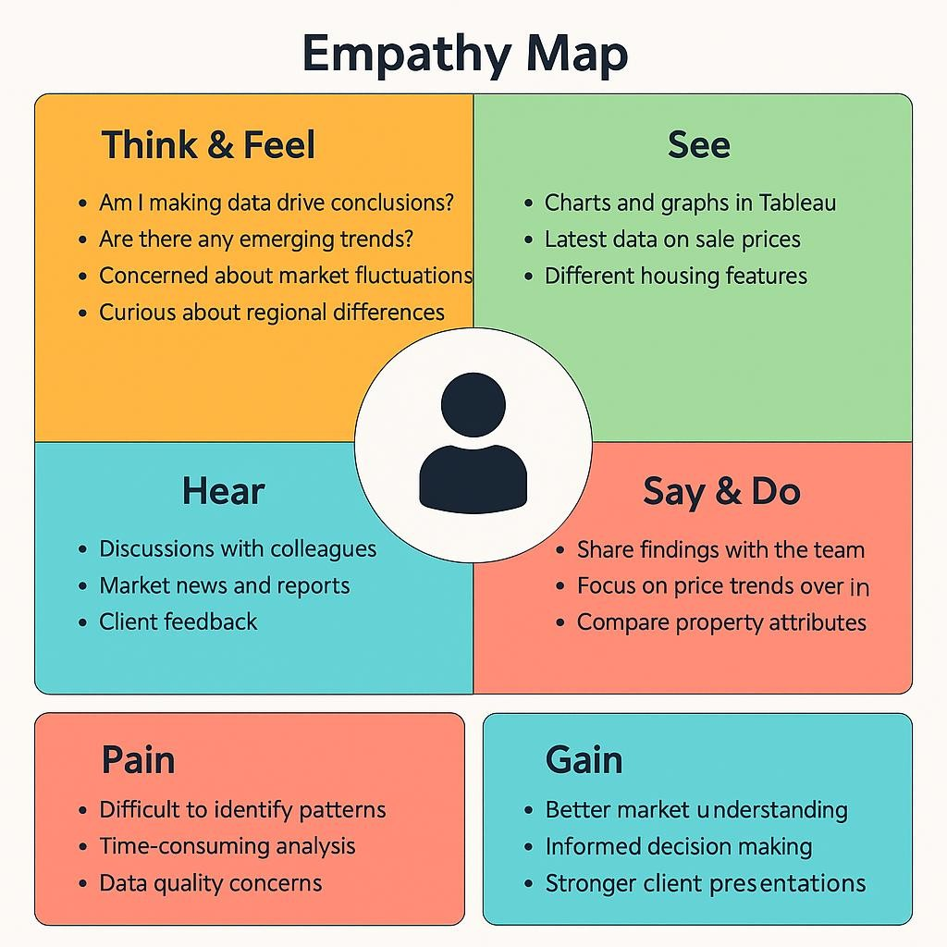

### 2.3 Brain Storming

**Step 1**: Team Gathering, Collaboration and Problem Statement

Our team collaborated to identify pressing challenges in the real estate market, particularly in understanding how various property features influence housing sale prices. After exploring themes like housing affordability, real estate investment planning, urban development, and smart property insights, we narrowed down our focus to uncover actionable insights hidden in housing data. The objective was to visually explore trends using Tableau that would help buyers, sellers, investors, and policy makers understand patterns of sale prices based on features like area, bedrooms, renovation status, condition, location (zipcode groups), and more.

**Problem Statement:**

How can housing sale price trends and property characteristics be visualized and analyzed using Tableau to identify patterns, improve buyer/seller decision-making, and uncover insights that support strategic real estate planning?

Team Members:

|  |  |  |
| --- | --- | --- |
| 1. Puppala naga venkata gowri sankar | | (Reg.No.23P31A4495) |
| 2. Nuvvula Jyothi sri |  | (Reg.No.23P31A4489) |

**Step 2:** Brainstorming, Idea Listing and Grouping

S.No Idea Description Category

1. Visualize average sale price by SalePriceBin Pricing Insights
2. Analyze impact of number of bedrooms on sale price Property Features
3. Explore relationship between Total Area and Price (scatter plot) Size-Based Pricing
4. Compare prices for renovated vs. non-renovated homes Renovation Analysis
5. Group insights by Zipcode Clusters Geographical Comparison
6. Analyze house condition vs. price using dummy variables Quality-Based Pricing
7. Add calculated field: TotalAreaSqft Data Preparation
8. Create SalePriceBin with 100k intervals Binning / Categorization
9. Use Tableau dashboard to combine insights Dashboard Design
10. Build a Story in Tableau for narrative Storytelling & Reporting

S.No Idea Description Category

1. Embed Dashboard in Web Application using Flask Deployment & Integration
2. Add filters for Bedrooms, Condition, Renovation in Dashboard Interactive Exploration

**Step 3**: Idea Prioritization Table

S.No Idea Description Impact Feasibility Priority

1. Visualize average sale price by SalePriceBin High Easy High
2. Analyze impact of number of bedrooms on sale price High Easy High
3. Explore TotalArea vs Price (scatter plot) High Easy High
4. Compare prices for renovated vs. non-renovated homes High Medium High
5. Group insights by Zipcode Clusters Medium Medium Medium
6. Analyze house condition vs. price High Medium High
7. Add calculated field: TotalAreaSqft Medium Easy High
8. Create SalePriceBin with 100k intervals Medium Easy High
9. Use Tableau dashboard to combine insights High Easy High
10. Build a Story in Tableau High Medium High
11. Embed Dashboard in Web Application High Hard Medium
12. Add filters for Bedrooms, Condition, Renovation Medium Easy Medium

## 3. Requirement analysis

### 3.1 Customer Journey map

#### Customer Journey Map: Housing Market Trends Dashboard

|  |  |  |  |  |
| --- | --- | --- | --- | --- |
| **Stage** | **Actions &**  **Touchpoints** | **Experience**  **Pain Points**  **& Emotions** | **Opportunities** | **User Goals** |

|  |  |  |
| --- | --- | --- |
| **Awareness** | * Sees dashboard via social media, newsletter,   Tableau Public   * Reads title/summary | Curious,  Interested |

|  |  |  |
| --- | --- | --- |
| Unclear if dashboard is relevant | Use benefit-driven  titles, visual thumbnails | Attract interest and clarify purpose |
| Overwhelmed by layout, unsure where to start | Add guided walkthrough, | Understand the dashboard |
| and its  simplify navigation features | |

|  |  |
| --- | --- |
| - Clicks dashboard link  Engaged,  **Consideration** - Reads  Cautious | |
|  | introduction, explores layout |
| **Exploration** | * Uses filters for   location, price,  features Excited,   * Views charts Inquisitive   (bar, scatter, pie, etc) |
| **Decision** | * Exports visuals * Shares dashboard   Satisfied, - Bookmarks or  Confident  downloads insights |
| **Retention** | * Subscribes for updates   Loyal,   * Revisits for new   Empowered  data   * Leaves feedback |

|  |  |
| --- | --- |
| Limited export options or unclear formats | Enable easy  Preserve and  download/share, share findings  offer export guides |
| No update notifications, feedback unacknowledged | Enable email  Stay informed  updates, actively and engaged  respond to feedback |

Add example Discover

Filters not intuitive, queries, improve valuable

charts slow to load

speed insights

### 3.2 Solution Requirement

#### Functional Requirements (FRs) FR

|  |  |  |
| --- | --- | --- |
| **No.** | **Functional Requirement (Epic) Sub Requirement (Story / Sub-Task)** | |
| FR-1 | **Data Import** | * Import data from CSV * Enable live database integration (MySQL) |
| FR-2 | **Data Cleaning & Transformation** | * Handle missing values * Add calculated fields like Year, Lockdown |
| FR-3 | **Data Visualization** | * Create Tableau worksheets * Build multiple dashboards |
| FR-4 | **User Interaction** | * Enable filtering by region, year * View comparative bar charts * Analyze pre/post-lockdown trends |
| FR-5 | **User Access** | * Role-based views for Analyst, Policy Maker,   Developer   * Download/export options |
| FR-6 | **Feedback Loop** | * Allow stakeholder feedback and change requests * Implement revision cycles |

#### Non-Functional Requirements (NFRs)

|  |  |
| --- | --- |
| **NFR Non-Functional**  **No. Requirement** | **Description** |
| NFR-1 **Usability** | Dashboard must be intuitive with clear filters, legends, and guided walkthroughs |
| NFR-2 **Security** | Implement role-based access and secure backend/database connectivity |
| NFR-3 **Reliability** | System must handle unexpected data formats and maintain high accuracy |
| NFR-4 **Performance** | Ensure fast loading and responsive interaction across all dashboard elements |
| NFR-5 **Availability** | Dashboard should be accessible across browsers/devices with minimal downtime |
| NFR-6 **Scalability** | Should scale for large datasets and support additional features/modules |

### 3.3 Data Flow Diagram

A Data Flow Diagram (DFD) is a traditional visual representation of the information flows within a system. A neat and clear DFD can depict the right

amount of the system requirement graphically. It shows how data enters and leaves the system, what changes the information, and where data is stored.

1. Data collected from POSOCO in CSV format.
2. Cleaned and transformed, with calculated fields like Year and Lockdown.
3. Visualizations built in Tableau using multiple worksheets.
4. Users review the dashboard and may request changes.
5. Final version archived after approval.

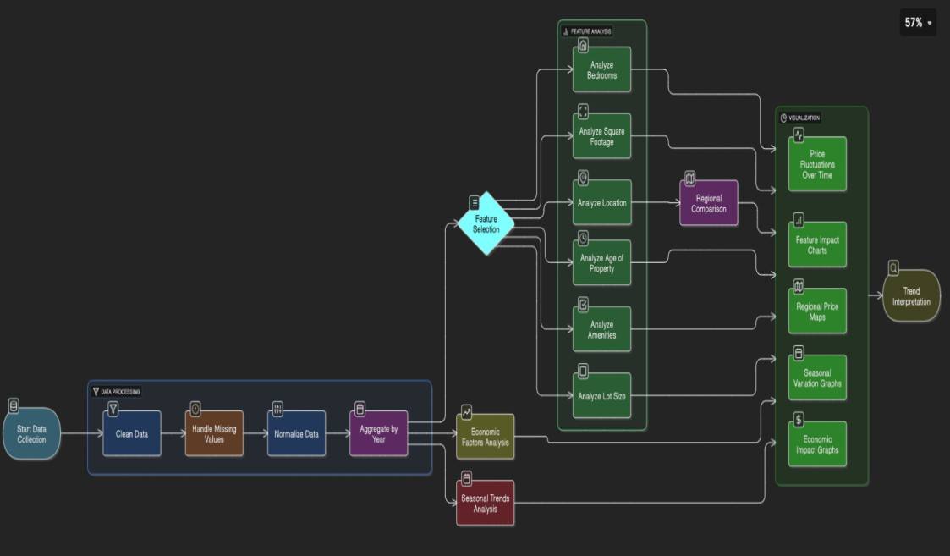

**User Stories Table:**

#### Functional User User Type Requirement Story User Story / Task Priority Release (Epic) Number

**Acceptance**

**Criteria**

As a user, I want to I can filter and

|  |  |  |  |
| --- | --- | --- | --- |
| View  Analyst /  Electricity USN-1  Policymaker  Trends | | view electricity view charts for Sprint-  High  usage trends by specific regions 1 region and year. and years. | |
| Analyst Compare States USN-2 | | As a user, I want to I can view bar  compare top and charts with top N Sprint-  Medium  bottom electricity- and bottom N 1 | |
| consuming states. states. |  |
| Forecast  Policy Maker USN-3  Planning | | I can view  As a user, I want to monthly and  analyze seasonal quarterly High  variations in usage. consumption  trends. | Sprint-  2 |
| Energy  Consultant | View Impact of  USN-4 Lockdown | As a user, I want to A before-after  compare electricity lockdown chart is  High  usage before and available for after lockdown. selection. | Sprint-  2 |
| Developer | Connect Data USN-5 | As a user, I want Data refreshes |  |
| the dashboard to be automatically Sprint-  Medium  connected to a live from MySQL to 2 database. Tableau. | |
| Developer | Export Insights USN-6 | As a user, I want to  I can download  export dashboard Sprint-  dashboards as Low  views for 3  images or PDFs.  presentations. | |

### 3.4 Technology Stack

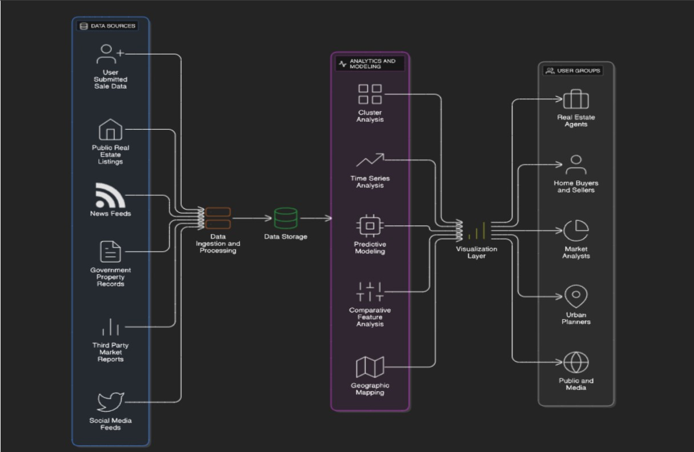

## 4. Project design

### 4.1 Problem Solution Fit

The Problem-Solution Fit simply means that you have found a problem with your customer and that the solution you have realized for it actually solves the customer’s problem. It helps entrepreneurs, marketers and corporate innovators identify behavioral patterns and recognize what would work and why.

**Purpose:**

❑ Solve complex problems in a way that fits the state of your customers.

❑ Succeed faster and increase your solution adoption by tapping into existing mediums and channels of behavior.

❑ Sharpen your communication and marketing strategy with the right triggers and messaging.

❑ Increase touch-points with your company by finding the right problem-behavior fit and building trust by solving frequent annoyances, or urgent or costly problems.

❑ Understand the existing situation in order to improve it for your target group.

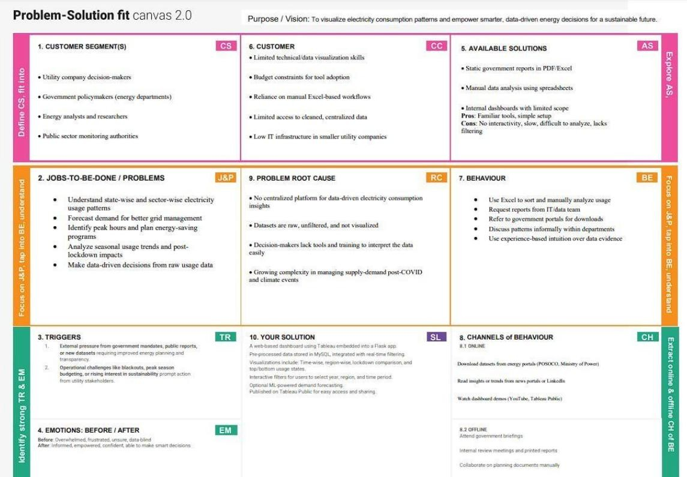

### 4.2 Proposed Solution

**Proposed Solution Template**

#### S.No. Parameter Description

The real estate market involves vast and complex datasets on housing

**Problem** features and sale prices. These datasets are often underutilized due to lack

**1**

**Statement** of effective visualization, making it difficult for buyers, sellers, and

analysts to draw insights or forecast trends.

Our solution transforms static housing datasets into interactive, insightful

visualizations using Tableau. The project involves cleaning and **Idea / Solution**

1. transforming the data, creating calculated fields and KPIs, and developing **Description** a dashboard that highlights key trends, comparisons, and location-based analyses. The solution is deployed via a Flask web app.

This project leverages Tableau’s powerful visual capabilities to go beyond

basic data analytics. By combining calculated fields, condition **Novelty /**

1. segmentation, and geographic mapping, the dashboard offers a dynamic **Uniqueness** exploration of how features like bedrooms, area, renovation, and location influence housing prices.

This solution enables real estate buyers, sellers, agents, and market

**Social Impact /** researchers to make informed decisions. It improves housing transparency,

#### 4 Customer

supports better urban planning, and enhances user engagement with clear

**Satisfaction** visuals and actionable insights.

This dashboard can be scaled and offered as a subscription-based SaaS tool

**Business Model** to real estate companies, market research firms, or housing consultancies.

#### 5 (Revenue

Advanced forecasting modules, API integrations, and custom dashboards

**Model)** can be monetized as premium features.

The system is designed to be scalable and adaptable. It can incorporate new

**Scalability of the** datasets (like rental trends or economic indicators), extend to new regions

**6**

**Solution** or cities, and integrate with ML models for price predictions, thereby

offering long-term growth potential.

### 4.3 Solution Architecture

Solution architecture is a complex process – with many sub-processes – that bridges the gap between business problems and technology solutions. Its goals are to:

* The architecture separates data preprocessing, storage, visualization, and UI layers—making it easy to maintain, scale, and enhance.
* Cleaned data from MySQL is visualized using Tableau dashboards, offering region-wise, year-wise, and seasonal insights with filtering capabilities.
* Dashboards are embedded into a Flask-based web interface, allowing end users to interact with visual data through a user-friendly portal.
* The solution supports future extensions like forecasting models and can be deployed locally or on cloud platforms like Heroku or AWS.

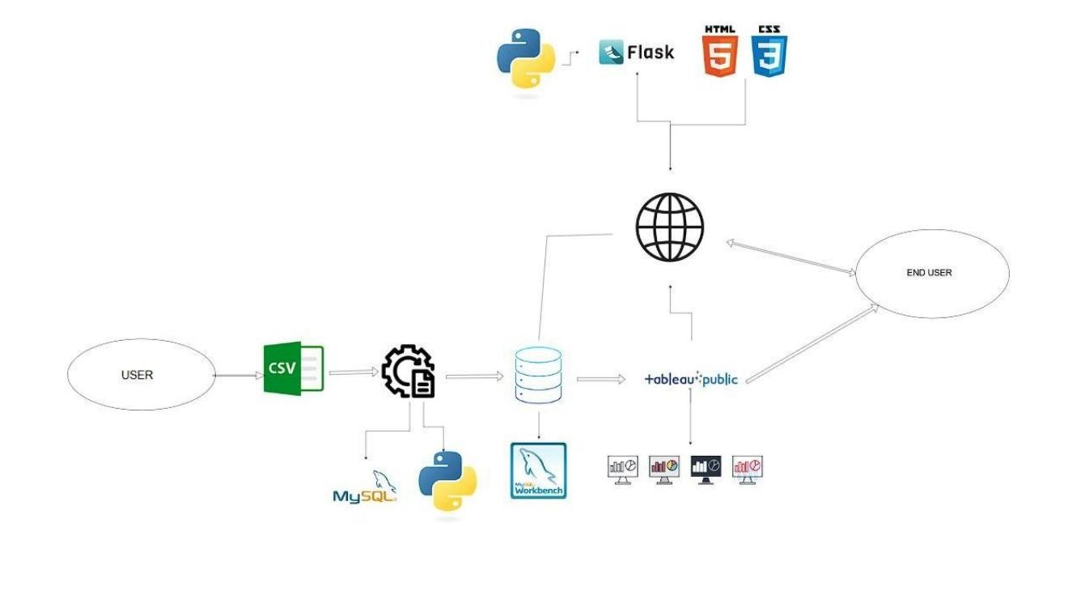

## 5. Project planning & scheduling

|  |  |  |  |
| --- | --- | --- | --- |
| **SprinEpic** | **User**  **User Story / Task**  **Story No** | **PointPriority** | **Assigned To** |

### 5.1 Project Planning

|  |  |  |
| --- | --- | --- |
| Sprint  Data Setup  1 | As a user, I can upload housing data in  USN-1 3  CSV format | High |

|  |  |  |
| --- | --- | --- |
| Flask Integratio USN-9 4  3 dashboard into a Flask web app | High |  |
| Sprint As a user, I can test and review the  Embed Testing USN-10 2 3 embedded dashboard UI | Medium |  |
| Sprint As a team, we can prepare final project  Documentation USN-11 3 4 documentation | High |  |
| SprintDemo As a team, we can prepare and rehearse  USN-12 2  4 Preparation a full demo walkthrough | Medium |  |

Sprint As a developer, I can embed Tableau **User**

#### SprinEpic User Story / Task PointPriority Assigned To Story No

Sprint As a team, we can test the full system

Bug Fixing / QAUSN-13 2 PUPPALA NAGA VENKATA GOWRI SANKAR

4 and fix visual/logic bugs

**Project Tracker, Velocity & Burndown Chart**

#### SprintTotal Story PointDuratioStart Date End Date Points CompleteRelease Dat

|  |  |  |
| --- | --- | --- |
| Sprint-11 | 4 Days 11 June 20214 June 20211 | 14 June 202 |
| Sprint-10 | 4 Days 15 June 20218 June 20210 | 18 June 202 |
| Sprint-7 | 4 Days 19 June 20222 June 2027 | 22 June 202 |
| Sprint-7 | 4 Days 23 June 20226 June 2027 | 26 June 202 |

#### Velocity Calculation

Total Points Completed: 11 + 10 + 7 + 7 = 35

Total Duration: 4 + 4 + 4 + 4 = 16 days

Average Velocity = Total Points Completed / Total Days = 35 / 16 = 2.19 points/day

#### Burndown Chart Insight

* Initial Total Story Points: 35
* Sprint-wise burn (Remaining Points):

o After Sprint-1: 24 o After Sprint-2: 14 o After Sprint-3: 7 o After Sprint-4: 0

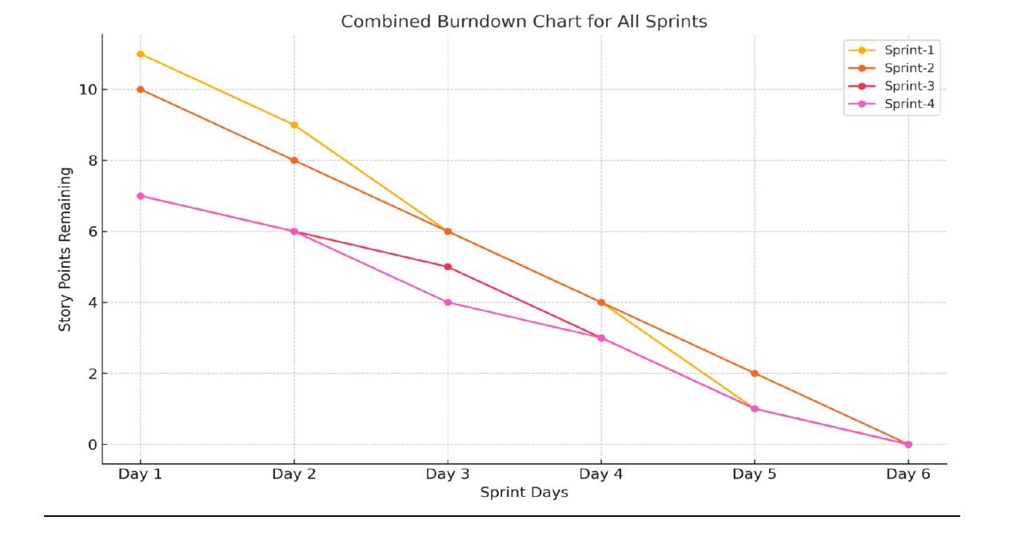

## 6. Functional and performance testing

### 6.1 Performance Testing

|  |  |  |
| --- | --- | --- |
| S.No | Parameter | Screenshot / Values |
| 1. | **Data Rendered** | The dataset used contains housing sales data with fields such as Sale  Price, Number of Bedrooms, Bathrooms, Flat Area, Lot Area,  Basement Area, House Age, Condition, Renovation Status, Zipcode Group, and others. The data was provided in .csv format and includes derived and transformed columns suitable for advanced analytics and visualizations in Tableau. |
| 2. | **Data Preprocessin** | **g**Before importing the data into Tableau, preprocessing was done usin Python (Pandas). The following steps were performed:   * Removed null or missing values. * Renamed columns for clarity (e.g., “No of Bedrooms” → “Bedrooms”). * Created calculated fields like “TotalAreaSqft” (sum of flat, and   basement areas).   * Generated dummy variables for house conditions and renovation status. * Transformed categorical fields to improve Tableau usability. The final cleaned dataset was stored and imported into Tableau for visualization. |

lo

|  |  |  |
| --- | --- | --- |
| 3. | **Utilization of Filters** | Multiple filters were implemented in Tableau to improve interactivity and user exploration. These include:   * Number of Bedrooms * Number of Bathrooms * House Condition * Renovation Status (Yes/No) * Zipcode Group * Sale Price Bins   These filters allow users to drill down and compare trends across different property types and regions. |
| 4 | **Calculated**  **Fields Used** | Several calculated fields were created in Tableau to enhance analysis and interactivity:   * TotalAreaSqft → [FlatAreaSqft] + [LotAreaSqft] +   [BasementAreaSqft]   * SalePriceBin → Binning Sale Price into ₹100,000 intervals * Condition_Excellent, Condition_Good, etc. → Dummy fields (0/ * Ever_Renovated_Yes → Dummy field to identify renovated home * AvgPrice → AVG([SalePrice]) for grouped insights * HouseAge → Difference between year built and sale date if available   (or derived field if pre-calculated)  These fields enable comparisons across pricing, condition, and space utilization. |

1)

|  |  |  |
| --- | --- | --- |
| 5 | **Dashboard** |  |

|  |  |  |
| --- | --- | --- |
| 6 | **Story Design** |  |

## 7. Results

### 7.1 Output Screenshots

#### Output of Sheet 1

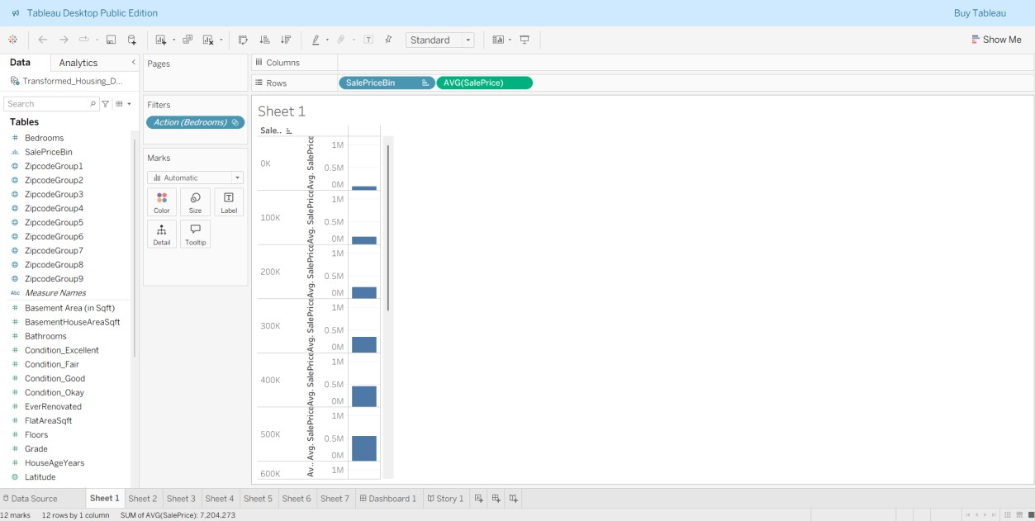

#### Output of Sheet 2

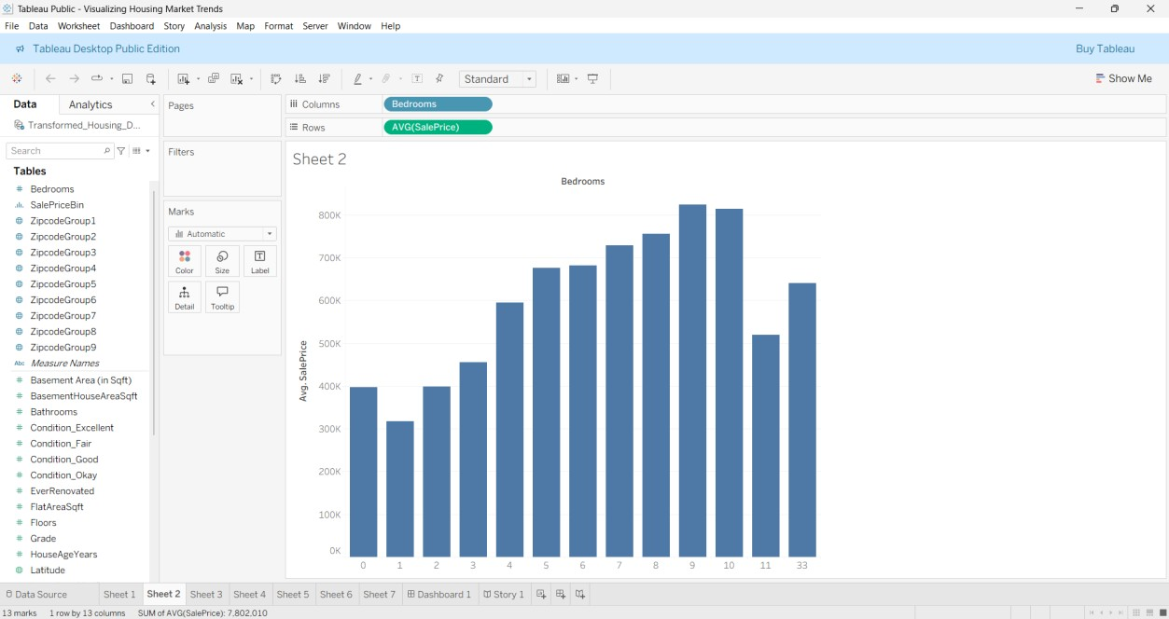

#### Output of Sheet 3

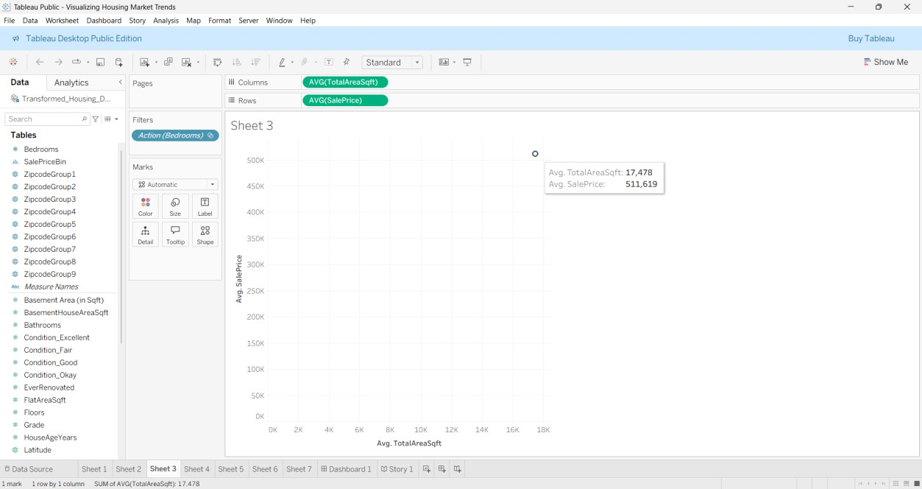

#### Output of Sheet 4

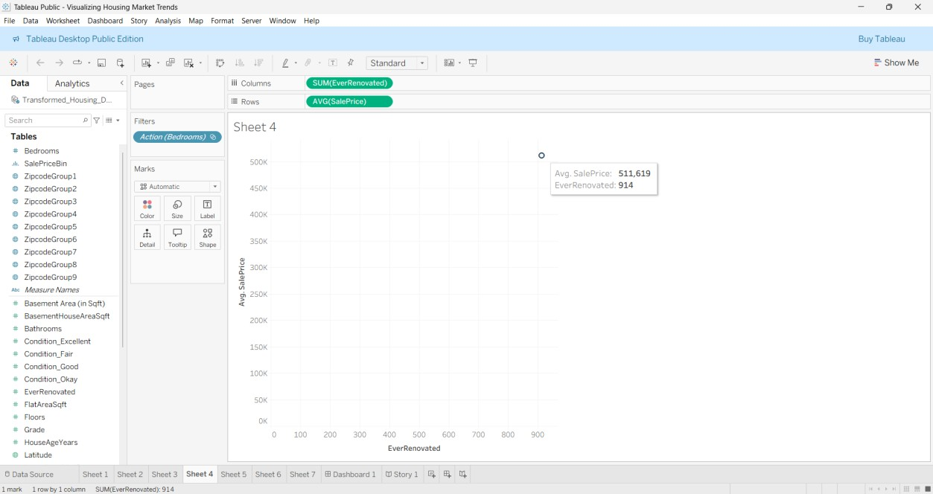

#### Output of Sheet 5

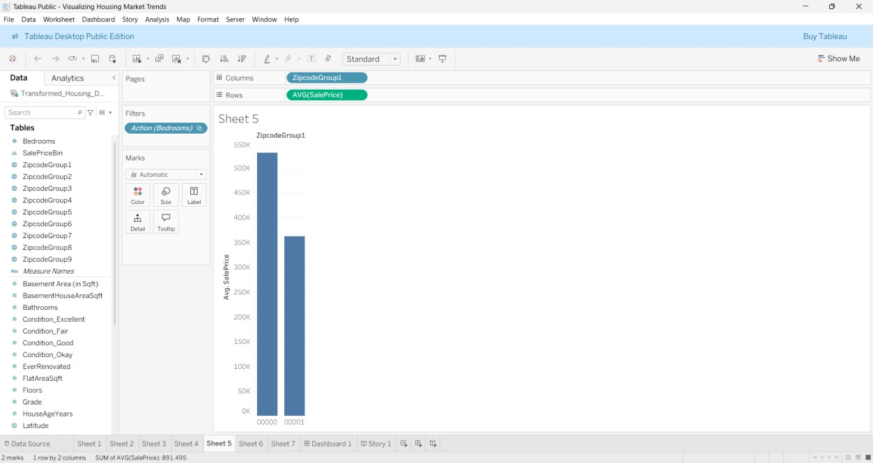

#### Output of Sheet 6

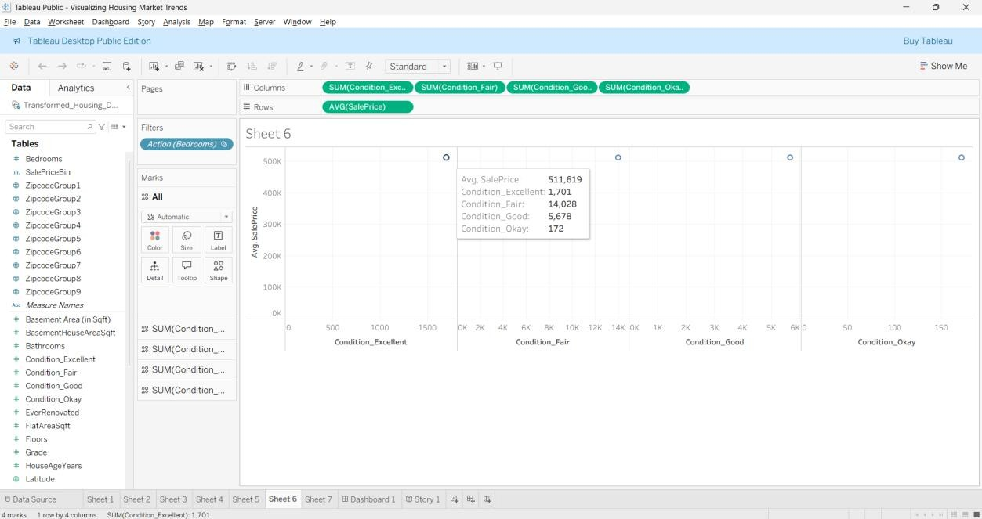

#### Output of Sheet 7

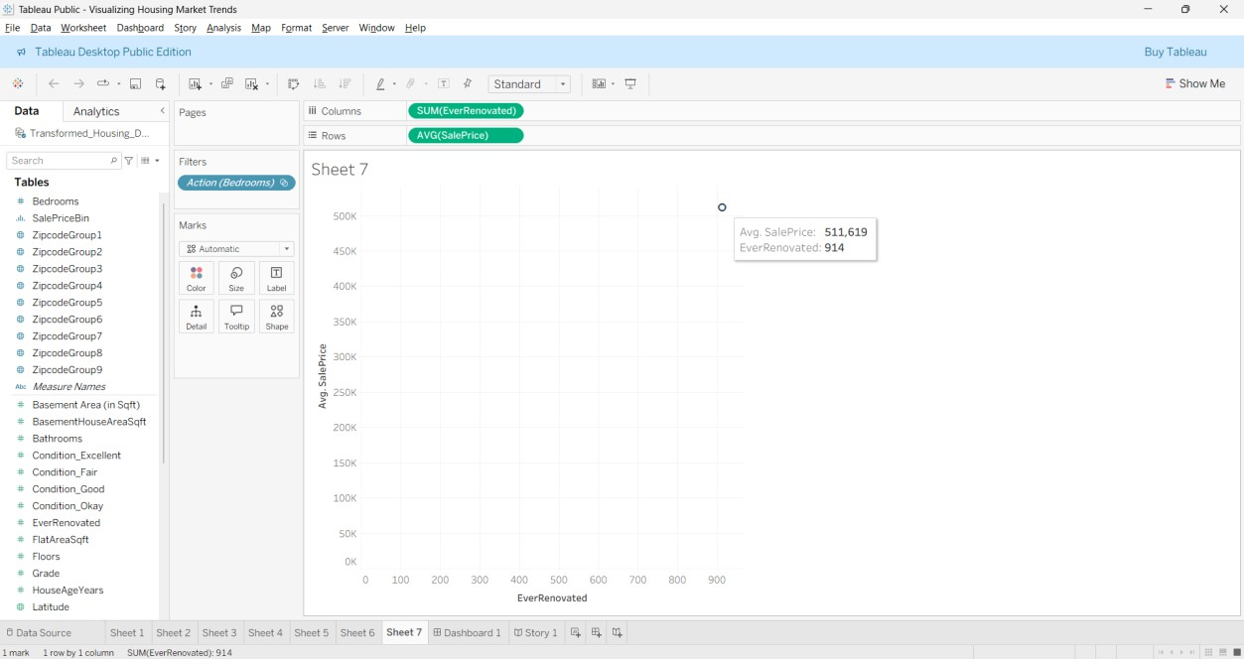

#### Output of Dashboard

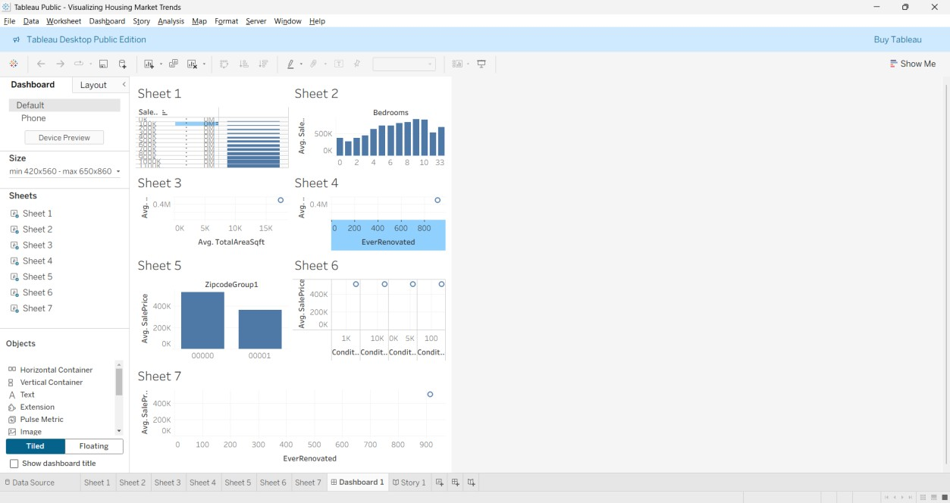

#### Output of Story

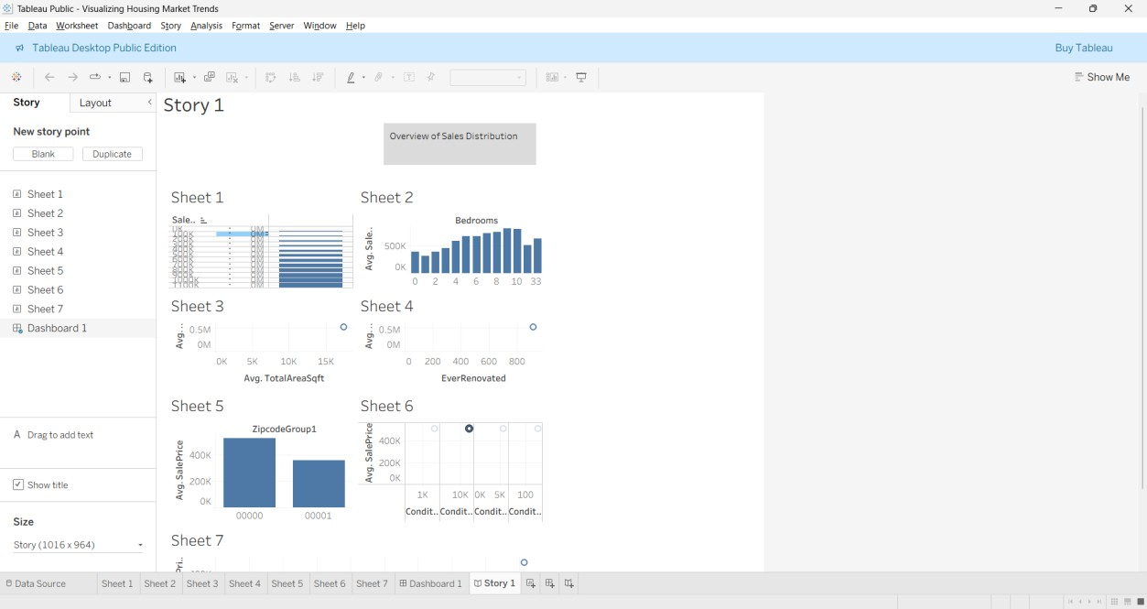

#### Tableau public link

[**https://public.tableau.com/views/VisualizingHousingMarketTrends_17508278225630/St ory1?:language=en-**](https://public.tableau.com/views/VisualizingHousingMarketTrends_17508278225630/Story1?:language=en-US&publish=yes&:sid=&:redirect=auth&:display_count=n&:origin=viz_share_link)

[**US&publish=yes&:sid=&:redirect=auth&:display_count=n&:origin=viz_share_link**](https://public.tableau.com/views/VisualizingHousingMarketTrends_17508278225630/Story1?:language=en-US&publish=yes&:sid=&:redirect=auth&:display_count=n&:origin=viz_share_link)

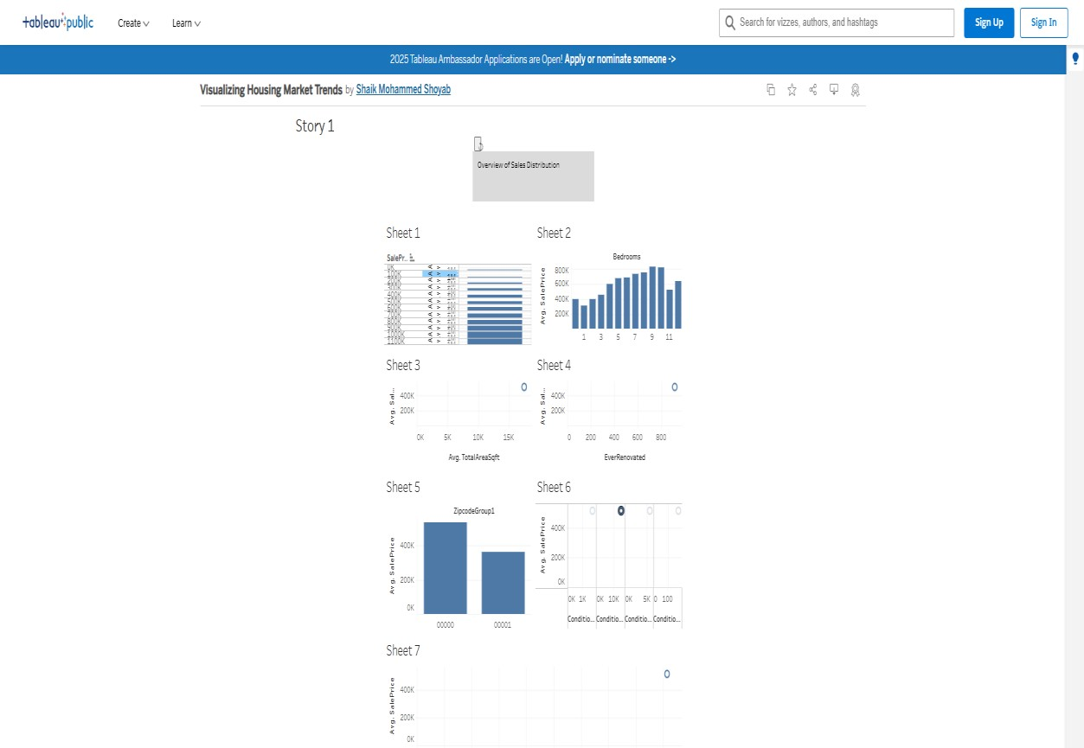

#### Output

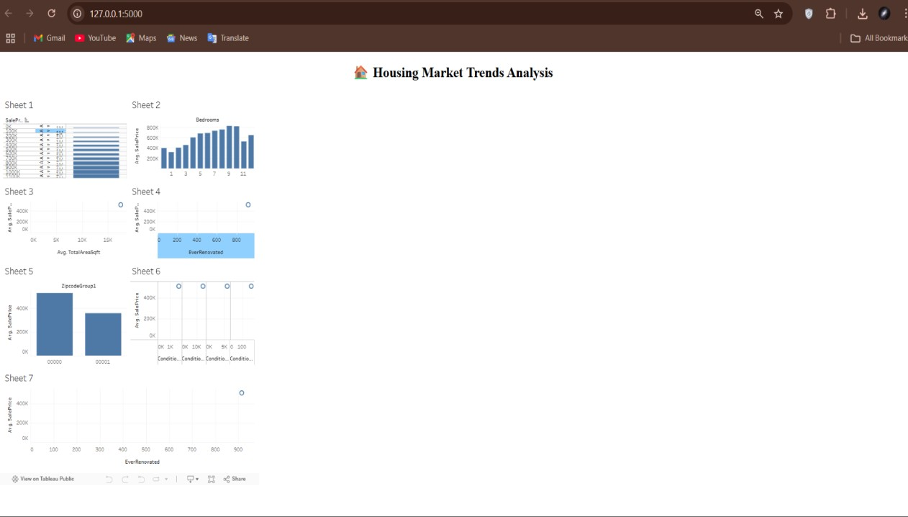

## 8. Advantages & disadvantages

**Advantages:**

1. **Interactive Analysis:**

The Tableau dashboard allows users to explore data with filters (e.g., bedrooms, renovation status, price bins), enhancing understanding through dynamic interactions.

1. **Informed Decision-Making:**

Buyers, sellers, agents, and investors can make data-driven decisions by identifying which features (e.g., area, renovations, number of floors) impact property value.

1. **Data Storytelling:**

The Tableau Story feature presents insights in a sequential, digestible narrative—great for business reports or stakeholder presentations.

1. **Geographic Visualization:**

Zipcode grouping allows regional comparison of price trends and property types, revealing market opportunities and local disparities.

1. **Calculated Metrics & KPIs:**

Metrics like Average Sale Price and Total Area improve business clarity and enable fast comparisons across categories.

1. **Web Accessibility:**

Embedding the dashboard into a Flask web app increases accessibility—users can view it from any browser without needing Tableau Desktop.

1. **Modular & Scalable Design:**

The project structure supports additional data (e.g., rental prices, future years), making it expandable to other regions or market conditions.

1. **Minimal Coding Required:**

Most of the visualizations are created using Tableau’s drag-and-drop interface—making it ideal for analysts without deep programming expertise.

**Disadvantages:**

1. **Static Dataset Limitation:**

The analysis depends on a preloaded CSV file; it doesn’t support real-time updates unless integrated with live databases or APIs.

1. **Tool Dependency:**

The system relies on Tableau Public, which has limitations like no row-level security and requires dashboards to be public.

1. **Learning Curve for Tableau:**

While Tableau is user-friendly, new users may need time to understand calculated fields, filters, and advanced charting options.

1. **Limited Predictive Power:**

This is a descriptive and visual analytics project—it does not use machine learning or predictive modeling to forecast housing prices.

1. **Browser Compatibility:**

Older browsers or low-resolution screens may not render complex dashboards optimally, especially if not designed responsively.

1. **Manual Data Preprocessing:**

Initial data cleaning, renaming, and transformation were done manually using Python or within Tableau, which might be error-prone at scale.

1. **Conclusion:**

The project "Visualizing Housing Market Trends: An Analysis of Sale Prices and Features using Tableau" successfully demonstrates how complex real estate data can be transformed into meaningful, interactive visual insights. By leveraging Tableau’s powerful visualization capabilities, we have made it easier for buyers, sellers, investors, and analysts to understand the key factors influencing house prices. Our dashboard enables quick comparisons based on features like number of bedrooms, renovations, house age, and geographic location. The integration with Flask provides a seamless web interface, enhancing accessibility and usability. Overall, this project bridges the gap between raw housing data and strategic real estate decision-making, allowing users to gain actionable insights with minimal technical expertise.

1. **Future scope:**

1. **Live Data Integration:**

Future versions can integrate live property listings or transaction data via APIs or real-time databases to provide up-to-date market insights.

1. **Machine Learning Forecasting:**

Incorporating regression models or time-series forecasting can help predict future housing prices based on historical trends and features.

1. **Rental Market Visualization:**

Extend the dashboard to include rental data analysis, enabling a broader comparison between buying vs. renting decisions.

1. **Mobile Optimization:**

Responsive design enhancements can be implemented to ensure the dashboard performs well across tablets and smartphones.

1. **Advanced User Access Control:**

By using Tableau Server or Tableau Online, dashboards can be secured with role-based access for different stakeholders.

1. **Location Intelligence Enhancements:**

Integration of geospatial data, satellite maps, or demographic overlays can improve locationbased insights (e.g., school zones, crime rates).

1. **Recommendation Engine:**

Develop a recommendation system to suggest optimal property types using user-input filters.

## 11. Appendix

### Source Code: index.html

<!-- templates/index.html -->

<!DOCTYPE html>

<html lang="en">

<head>

<meta charset="UTF-8">

<title>Housing Market Dashboard</title>

</head>

<body>

<h1 style="text-align: center;"> Housing Market Trends Analysis</h1>

<div class='tableauPlaceholder' id='viz1750827980701' style='position: relative'>

<noscript>

<a href='#'>

<img alt='Dashboard 1 '

src='https://public.tableau.com/static/images/Vi/VisualizingHousingMarketTrends_17508278 225630/Dashboard1/1_rss.png' style='border: none' />

</a>

</noscript>

<object class='tableauViz' style='display:none;'>

<param name='host_url' value='https%3A%2F%2Fpublic.tableau.com%2F' />

<param name='embed_code_version' value='3' />

<param name='site_root' value='' />

<param name='name'

value='VisualizingHousingMarketTrends_17508278225630&#47;Dashboard1' />

<param name='tabs' value='no' />

<param name='toolbar' value='yes' /> <param name='static_image'

value='https://public.tableau.com/static/images/Vi/VisualizingHousingMarketTrends_175082

78225630/Dashboard1/1.png' />

<param name='animate_transition' value='yes' />

<param name='display_static_image' value='yes' />

<param name='display_spinner' value='yes' />

<param name='display_overlay' value='yes' />

<param name='display_count' value='yes' />

<param name='language' value='en-US' />

<param name='filter' value='publish=yes' />

</object>

</div>

<script type='text/javascript'>

var divElement = document.getElementById('viz1750827980701'); var vizElement = divElement.getElementsByTagName('object')[0]; if (divElement.offsetWidth > 800) { vizElement.style.minWidth = '420px'; vizElement.style.maxWidth = '650px'; vizElement.style.width = '100%'; vizElement.style.minHeight = '587px'; vizElement.style.maxHeight = '887px';

vizElement.style.height = (divElement.offsetWidth * 0.75) + 'px';

} else if (divElement.offsetWidth > 500) { vizElement.style.minWidth = '420px'; vizElement.style.maxWidth = '650px'; vizElement.style.width = '100%'; vizElement.style.minHeight = '587px'; vizElement.style.maxHeight = '887px';

vizElement.style.height = (divElement.offsetWidth * 0.75) + 'px';

} else {

vizElement.style.width = '100%'; vizElement.style.height = '1527px';

}

var scriptElement = document.createElement('script');

scriptElement.src = 'https://public.tableau.com/javascripts/api/viz_v1.js'; vizElement.parentNode.insertBefore(scriptElement, vizElement);

</script>

</body>

</html>

### app.py

from flask import Flask, render_template

app = Flask(__name__)

@app.route('/') def home():

return render_template('index.html')

if __name__ == '__main__': app.run(debug=True)

**Project Structure** housing_dashboard/

├── app.py # Flask server that renders the homepage

└── index.html # Web page embedding the Tableau dashboard

**Dataset Link** [https://docs.google.com/spreadsheets/d/1blBKrwunCQaiccy5sLP6mG4TsanJkO0C/edit?usp =drive_link&ouid=117818466889783119367&rtpof=true&sd=true](https://docs.google.com/spreadsheets/d/1blBKrwunCQaiccy5sLP6mG4TsanJkO0C/edit?usp=drive_link&ouid=117818466889783119367&rtpof=true&sd=true)

**Project Demo Video Link** [https://drive.google.com/file/d/1JGCDvR1v3psEj5MYBe8YCGDNrLE6oKFX/view?usp=dri ve_link](https://drive.google.com/file/d/1JGCDvR1v3psEj5MYBe8YCGDNrLE6oKFX/view?usp=drive_link)

### GitHub Repository Link

https://github.com/PuppalaNagaVenkataGowriSankar/Visualizing-Housing-Market-Trends-An-Analysis-of-Sale-Prices-and-Features-using-Tableau